**ASSIGNMENT 3**

**1. ABSTRACT**

Database normalization is the process of organizing the attributes and tables of a relational database to minimize data redundancy. In this assignment the database (Movies Database) built in the previous assignment is normalized (1NF, 2NF, 3NF). The final SQL of a normalized database is presented. Views for all of your use-cases are created. Five indexes, functions and procedures are created on the normalized database.

**2. NORMALIZATION:**

The Database before normalization contained four tables (1 for company entity, 1 for producer entity, 2 for consumer entity) and was as follows:

CREATE TABLE company(

title VARCHAR(255) PRIMARY KEY NOT NULL,

Release_date DATE,

Overview VARCHAR(255),

Adult VARCHAR,

Vote_count INT,

Vote_average FLOAT,

Popularity FLOAT

);

CREATE TABLE producer(

title VARCHAR(255) PRIMARY KEY NOT NULL,

production_companies VARCHAR(255),

production_countries VARCHAR(255),

revenue INTEGER

);

CREATE TABLE consumer(

Name VARCHAR(255) PRIMARY KEY NOT NULL,

User_id INTEGER,

Followers INTEGER,

Post STRING,

Hashtags STRING,

Posted_time STRING,

Favourites INTEGER

);

CREATE TABLE tweets(

title VARCHAR(255) PRIMARY KEY NOT NULL,

name VARCHAR(255),

FOREIGN KEY(name) REFERENCES consumer(Name)

);

**SAMPLE DATABASE TABLES BEFORE NORMALIZATION:**

Company – Movies



Producer – Production house



Consumer – Movie viewers





After Normalization, the database is modified and follows the below schema:

Company Entity:

CREATE TABLE company1 (

Movie_id INTEGER PRIMARY KEY AUTOINCREMENT

NOT NULL,

Movie_title VARCHAR (255),

Release_date DATE,

Overview VARCHAR (255),

Vote_count INT,

Vote_average FLOAT,

Popularity FLOAT

);

Production Entity:

CREATE TABLE production1 (

id INTEGER PRIMARY KEY

NOT NULL,

title VARCHAR (255),

revenue INTEGER

);

CREATE TABLE production_company (

title VARCHAR (255) REFERENCES production1 (title),

production_company_name VARCHAR (255),

FOREIGN KEY (title) REFERENCES production1 (title)

);

CREATE TABLE production_country (

title VARCHAR (255) REFERENCES production1 (title),

production_country_name VARCHAR (255),

FOREIGN KEY (title) REFERENCES production1 (title)

);

Consumer Entity:

CREATE TABLE consumer_user_info (

User_id INTEGER PRIMARY KEY

NOT NULL,

Name VARCHAR (255),

Followers INTEGER,

title VARCHAR (255),

User_name VARCHAR (255)

);

CREATE TABLE consumer_tweet_info (

User_id INTEGER,

Post STRING,

Hashtags STRING,

Posted_time STRING,

Favourites INTEGER,

FOREIGN KEY (User_id) REFERENCES consumer_user_info (User_id)

);

﻿

**SAMPLE DATABASE TABLES AFTER NORMALIZATION:**

Company – Movies

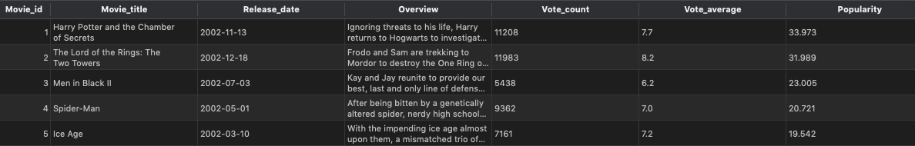

Producer:

Production -

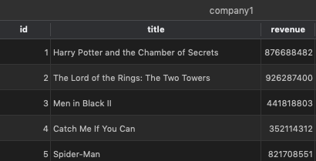

Production Company -

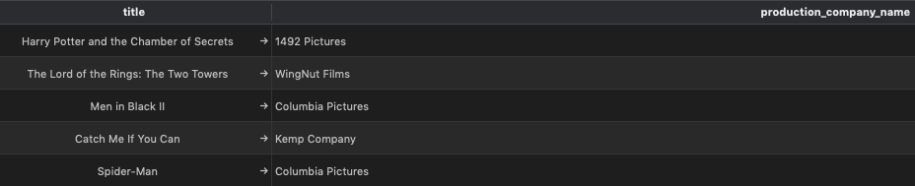

Production Country –

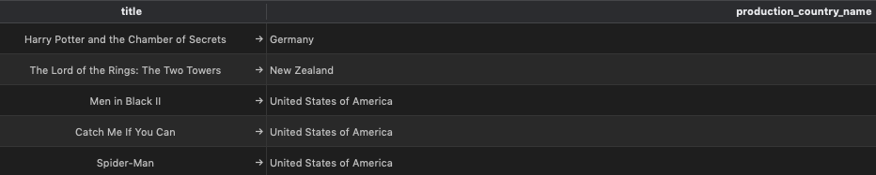

Consumer – Movie viewers

Consumer User Info -

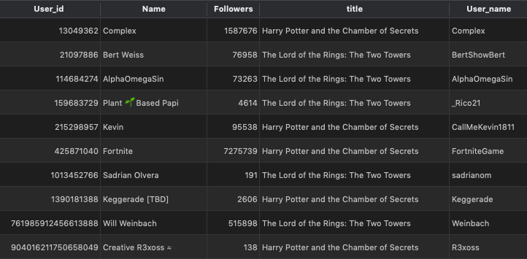

Consumer tweets info -

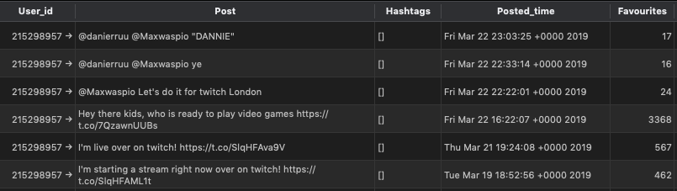

Normalization steps performed:

Table Producer:

1. The attributes production_companies and production_countries were multivalued attributes, so new tables are created for these such as Production Company and Production Country connected to the Production table via Foreign keys.

Table Consumer:

1. Consumer table had information that did not depend on the primary key and hence the information is split to two tables such as Consumer User Info and Consumer tweets info
2. The transitive dependencies in the Consumer table has been eliminated.

Normalization is done to satisfy the following conditions:

First normal form (1NF)

• Each table has a primary key: minimal set of attributes which can uniquely identify a record

• The values in each column of a table are atomic (No multi-value attributes allowed)

• There are no repeating groups: two columns do not store similar information in the same table.

Second normal form (2NF)

• All requirements for 1st NF must be met.

• No partial dependencies.

• No calculated data

Third normal form (3NF)

• All requirements for 2nd NF must be met.

• Eliminate fields that do not directly depend on the primary key; that is no transitive dependencies.

Company:

|  |
| --- |
| Title |
| Release_date |
| Overview |
| Adult |
| Vote_count |
| Vote_average |
| Popularity |

|  |
| --- |
| Movie_ID |
| Title |
| Release_date |
| Overview |
| Vote_count |
| Vote_average |
| Popularity |

Producer:

|  |
| --- |
| Title |
| Production_companies |
| Production_countries |
| Revenue |

|  |
| --- |
| Movie_ID |
| Title |
| Revenue |

|  |
| --- |
| Title |
| Production_company_names |

|  |
| --- |
| Title |
| Production_country_names |

Consumer:

|  |
| --- |
| User_ID |
| Name |
| Folowers |
| Title |
| User_Name |

|  |
| --- |
| Name |
| User_ID |
| Folowers |
| Post |
| Hashtags |
| Posted_time |
| Favorites |

|  |
| --- |
| User_ID |
| Post |
| Hashtags |
| Posted_time |
| Favorites |

|  |
| --- |
| Title |
| Screen_Name |

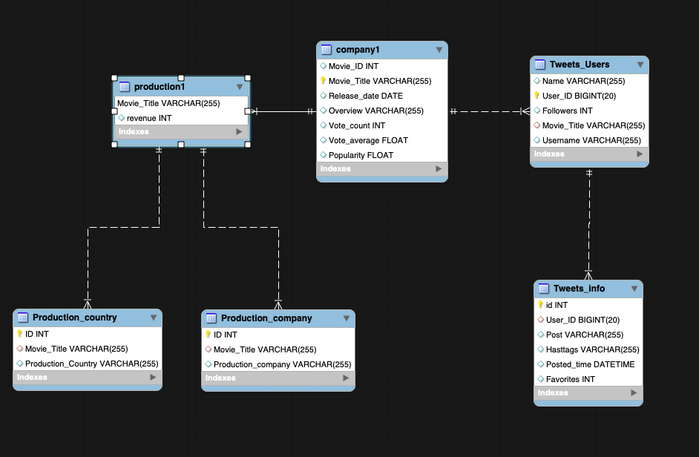

**3. VIEWS FOR ALL USE-CASES**

**Use case 1**: Query for finding name and revenue of the movie

View:

create view as ﻿Query_UC_1_Company_Production_View_1

select company1.Movie_title, company1.Release_date, production1.revenue

from company1, production1

where company1.Movie_title = production1.title

**Use case 2:** Query for overview and popularity

View:

create view as ﻿Query_UC_2

select company1.Movie_title, company1.Release_date, company1.Overview, company1.Popularity

from company1

**Use case 3:** Query for finding release_date, overview, vote_count, vote_average, popularity

View:

create view as ﻿Query_UC_3

select company1.Movie_title, company1.Release_date, company1.Overview, company1.Vote_count, company1.Vote_average, company1.Popularity

from company1

**Use case 4 & 5:** Query for finding the movies and their revenue

View:

create view as ﻿Query_UC_4_5

select production1.title, production1.revenue

from production1

**Use case 6:** Query for finding twitter user with maximum followers

View:

create view as ﻿Query_UC_6

select consumer_user_info.User_id, consumer_user_info.User_name, consumer_user_info.Followers

from consumer_user_info

**Use case 7:** Query to get the tweets and the posted time of the tweets of the user with maximum followers

View:

create view as ﻿Query_UC_7

select consumer_user_info.User_id, consumer_user_info.User_name, consumer_user_info.Followers, consumer_tweet_info.Post, consumer_tweet_info.Posted_time

from consumer_user_info, consumer_tweet_info

where consumer_user_info.User_id=consumer_tweet_info.User_id

**Use case 8:** Query to find the movie with revenue among the movies tweeted by twitter users

View:

create view as ﻿Query_UC_8

select consumer_user_info.User_id, consumer_user_info.User_name, consumer_user_info.title, production1.revenue

from consumer_user_info, production1

where consumer_user_info.title=production1.title

**Use case 9:** Query to get the movie overview, release date and name of the twitter user for movies that the users have tweeted about

View:

create view as ﻿Query_UC_9

select consumer_user_info.User_id, consumer_user_info.User_name, consumer_user_info.title, company1.Release_date, company1.Overview

from consumer_user_info, company1

where consumer_user_info.title=company1.Movie_title

**Use case 10:** Query for the twitter user and twitter posts

View:

create view as ﻿Query_UC_10

select consumer_user_info.User_id, consumer_user_info.User_name, consumer_tweet_info.Post, consumer_tweet_info.Posted_time

from consumer_user_info, consumer_tweet_info

where consumer_user_info.User_id=consumer_tweet_info.User_id

**Use case 11:** Query for title, overview, release date of the movie the twitter users posted about

View:

create view as ﻿Query_UC_11

select consumer_user_info.User_id, consumer_user_info.User_name, consumer_tweet_info.Post, consumer_tweet_info.Posted_time

from consumer_user_info, consumer_tweet_info

where consumer_user_info.User_id=consumer_tweet_info.User_id

**4. INDEXES**

The following indexes are created:

1. Company table which improves the performance for use cases 1, 2, 3:

CREATE INDEX I1_title_release_date ON company1 (

Movie_title ASC,

Release_date

);

=> Query execution time reduced from 0.002 second(s) to 0.001 second(s).

2. Company table which improves the performance for use cases 2 & 3:

CREATE INDEX I2_title_popularity ON company1 (

Movie_title ASC,

Popularity

);

=> Query execution time reduced from 0.002 second(s) to 0.001 second(s).

3. Production table which improves the performance for use cases 1, 4 & 5:

CREATE INDEX I1_Title_Revenue ON production1 (

title,

revenue

);

=> Query execution time reduced from 0.002 second(s) to 0.001 second(s).

4. Production_company table:

CREATE INDEX I1_productionCompany ON production_company (

production_company_name

);

=> Query execution time reduced from 0.002 second(s) to 0.001 second(s).

5. Production_country table:

CREATE INDEX I1_ProductionCountry ON production_country (

production_country_name

);

=> Query execution time reduced from 0.002 second(s) to 0.001 second(s).

6. Consumer_user_info table which improves the performance for use cases 6,7,8,9,10 & 11:

CREATE INDEX I1_UserID_Username ON consumer_user_info (

User_id,

User_name

);

=> Query execution time reduced from 0.002 second(s) to 0.001 second(s).

7. Consumer_user_info table which improves the performance for use cases 8,9 & 11:

CREATE INDEX I2_UserID_Username_title ON consumer_user_info (

User_id,

title,

User_name

);

=> Query execution time reduced from 0.002 second(s) to 0.001 second(s).

8. Consumer_tweet_info table which improves the performance for use cases 7 & 10:

CREATE INDEX I1_post_postedtime ON consumer_tweet_info (

Post,

Posted_time

);

=> Query execution time reduced from 0.002 second(s) to 0.001 second(s).

**5. FUNCTIONS**

* Function (1): number_of_tweets() using 'consumer_user_info' and 'consumer_tweet_info'

#Description: Accepts User_name as input and returns the total number of tweets made by the user.

#Joins used: Tables 'consumer_user_info' and 'consumer_tweet_info' are joined using 'User_ID'.

DELIMITER $$

CREATE DEFINER=`root`@`localhost` FUNCTION `number_of_tweets`(user_name text) RETURNS int

READS SQL DATA

BEGIN

DECLARE number_of_tweets INT;

*SELECT count(t.Post) INTO number_of_tweets*

*FROM consumer_tweet_info t, consumer_user_info u*

*WHERE t.User_ID = u.User_ID;*

*RETURN number_of_tweets;*

*END$$*

*DELIMITER ;*

* Function (2): number_of_posts() using 'consumer_tweet_info'

#Description: Accepts user_id as input and returns the total number of posts made by the user.

#Joins used: Table 'consumer_tweet_info' is alone used.

*DELIMITER $$*

*CREATE DEFINER=`root`@`localhost` FUNCTION `*consumer_tweet_info*`(user_id varchar(255)) RETURNS int*

READS SQL DATA

*BEGIN*

*DECLARE number_of_posts INT;*

*SELECT count(p.Post) INTO number_of_posts*

*FROM consumer_tweet_info p*

*WHERE p.User_ID = user_id;*

*RETURN number_of_posts;*

*END$$*

*DELIMITER ;*

* Function (3) : dates_of_movie_tweets()

#Description: Accepts movie name as input and returns the concatenated list of dates(extracting only date from datetime stamp),

#Joins used:

#1.Tables 'consumer_user_info' and 'consumer_tweet_info' are joined using 'User_ID'.

*DELIMITER $$*

*CREATE DEFINER=`root`@`localhost` FUNCTION `dates_of_movie_tweets`(movie text) RETURNS text*

*READS SQL DATA*

*BEGIN*

*DECLARE dates text;*

*select group_concat(DISTINCT(Date(t.Posted_Time))) INTO dates*

*from consumer_tweet_info t, consumer_user_info p*

*where t.user_ID = p.user_ID;*

*RETURN dates;*

*END$$*

*DELIMITER ;*

*\**Function (4) : dates_of_user_tweets()

#Description: Accepts User name as input and returns the concatenated list of dates(extracting only date from datetime stamp),

# Function call for movie_names_attached_to_posts_on_selected_day() with '2019-03-22' as input

select Movie_names_attached_to_posts_on_selected_day('2019-03-22') as 'Movie Names';

#on which tweets were made about movies.

#Joins used:

#1.Tables 'consumer_user_info' and ''consumer_tweet_info ' are joined using 'User_ID'.

*DELIMITER $$*

*CREATE DEFINER=`root`@`localhost` FUNCTION `dates_of_movie_tweets`(moviename text) RETURNS text*

*READS SQL DATA*

*BEGIN*

*DECLARE dates text;*

*select group_concat(DISTINCT(Date(t.Posted_Time))) INTO dates*

*from consumer_tweet_info t, consumer_user_info p*

*where t.User_ID = p.User_ID;*

*RETURN dates;*

*END$$*

*DELIMITER ;*

* Function (5): Accepts revenue as the input and classifies it as high grossing or low grossing movie

#Description: Accepts revenue of the movie as input and returns if the movie is a high grosser or low grosser based on the below logic

If revenue is greater than 100000000 it is a high grosser else a low grosser

#Tables used: Production1

*DELIMITER $$*

*CREATE DEFINER=`root`@`localhost` FUNCTION `predict_movie_type`(revenue)) RETURNS text*

*READS SQL DATA*

*BEGIN*

*DECLARE Movie_type text;*

*IF revenue > 100000000 THEN*

*SET Movie_type = “high_grosser_movie”;*

*ELSE*

*SET Movie_type = “low_grosser_movie”;*

*END IF;*

*RETURN Movie_type;*

*END$$*

*DELIMITER ;*

**6. STORED PROCEDURES**

* stored Procedure (1) : Movie_specific_tweets_made_on_selected_date()

#Description: Consists of Posted_time as input parameter and returns the list of all tweets made on the

#input date, which is categorized with movie name.

#Joins used: Tables 'consumer_user_info' and 'consumer_tweet_info' are joined using 'User_ID'.

*DELIMITER $$*

*CREATE DEFINER=`root`@`localhost` PROCEDURE `movie_specific_tweets_made_on_selected_date`(IN Posted_time date)*

*READS SQL DATA*

*BEGIN*

*SELECT p.title as 'Movie Name', t.Content*

*FROM consumer_user_info t, consumer_tweet_info p*

*WHERE p.User_ID = t.User_ID*

*AND t.Posted_Time between (tweetdate) and timestamp (tweetdate, '23:59:59');*

*END$$*

*DELIMITER ;*

# Procedure call for movie_specific_tweets_made_on_selected_date() with '2019-03-02' as input parameter

Call movie_specific_tweets_made_on_selected_date ('2019-03-02');

drop procedure movie_specific_tweets_made_on_selected_date;

#stored Procedure (2) : User_specific_posts_made_on_selected_date()

#Description: Consists of postdate as input parameter and returns the list of all posts made by user

#Joins used: Tables 'consumer_user_info' and 'consumer_tweet_info' are joined using 'User_ID'.

*DELIMITER $$*

*CREATE DEFINER=`root`@`localhost` PROCEDURE `user_specific _posts_made_on_selected_date`(IN posted_time date)*

*READS SQL DATA*

*BEGIN*

*SELECT posted_time*

*FROM consumer_user_info t, consumer_tweet_info p*

*WHERE p.User_ID = i.User_ID*

*AND post.Created_Time between (postdate) and timestamp (postdate, '23:59:59');*

*END$$*

*DELIMITER ;*

#stored Procedure (3) : users_with_most_retweeted_tweets()

#Description: Consists of number_of_users as input parameter and returns the list of twitters users(userID, username and user secreen name),

#where number of results is controlled by the input paramater

#Joins used: Tables 'consumer_user_info' and 'consumer_tweet_info' are joined using 'User_ID'.

*DELIMITER $$*

*CREATE DEFINER=`root`@`localhost` PROCEDURE `users_with_most_retweeted_tweets`(IN number_of_users INT)*

*READS SQL DATA*

*BEGIN*

*SELECT sum(t.post_Count) as 'Post Count', u.User_ID, u.User_Name,u.User_Screen_Name*

*FROM consumer_user_info t, consumer_tweet_info p*

*where t.User_ID = u.User_ID*

*group by u.User_ID*

*order by sum(t.post) DESC*

*END$$*

*DELIMITER ;*

*DELIMITER $$*

**7. AUDIT VALIDITY:**

The database had some json objects which has been cleaned and the dataset contains no null values and is clean and complete. Few columns have been renamed for the purpose of making simple, understandable and relatable.

**8. AUDIT COMPLETENESS**

The dataset is up to date, needs no more cleaning and matches the quality of the real world data.

**9. AUDIT CONSISTENCE/UNIFORMITY:**

The possible range of the dataset is covered from the new resultant data set. The data does not have any null values, limitations, negative values.

**10. CONCLUSION:**

In the assignment, all of the database tables were populated with real-word data collected from three sources: TMDB API, Twitter API, and kaggle. A conceptual schema was designed for Movies domain involving companies, producers, consumers and subsequently a physical model was also established. The collected data was reformatted, cleaned to fit the database schema and populated into the database. The database was further normalized, views were created for the use cases. Indexes were created to improve the performance of the Queries. User defined functions and procedures are defined.

**11. CITATIONS AND REFERENCES:**

1. Geeks for Geeks - https://www.geeksforgeeks.org

2. Github - https://github.com/nikbearbrown/INFO_6210

3. Google

4. Kaggle

5. Youtube

6. Stack Overflow